Go above and beyond for your client.
Tools you can customise by OnePath Life Insurance
CATEGORY – Wading through the complexity

TOPIC – Top 3 things you need to know about life insurance

SOCIAL MEDIA
Use or customise the below post most likely to resonate with your clients via social media such as LinkedIn or Twitter. Your posts can link directly to the articles on our website, or you can customise a link to your own white-labelled versions of the articles.
Tip: Spread the word with #clarity
#clarity is a hashtag we’ve added to the material to promote life insurance education. We encourage you to get on board and help grow engagement and confidence in the life insurance industry by using it when you post on social media.

SOCIAL MEDIA POST
If you’re like most people, you probably have some form of life cover already. But how much do you really know about this important type of life insurance? Read more #clarity
<Link to the article below either on your website or within the social platform>

FLYER/NEWSLETTER/WEBSITE ARTICLE
This article has been white-labelled to allow you to use the content (without having to seek our permission) as a customer flyer, newsletter or on your website.
Tip: Complement your advice
You could also use the articles to complement your advice, sending specific articles to clients who have expressed concerns about their insurance or who have yet to take up insurance you have recommended.

ARTICLE
Life cover 101
It may be the simplest form of life insurance, but life cover is undoubtedly one of the most important as it helps you provide for your debts and dependants. When you’re looking at life cover, there are 3 key things you need to understand so you know what will happen at claim time:
- How much you’re covered for
- How your policy will be paid out
- How your cover is structured – linked or stand-alone
- How much you’re covered for
It might sound obvious, but you need to think about the reasons you take out life cover when you apply for cover. You might think “$1 million should be enough” – but have you thought about how much money would really be needed to replace your income, support your family, educate your children etc.?
The Australian Securities and Investments Commission (ASIC) has developed a Life insurance calculator <link to https://www.moneysmart.gov.au/tools-and-resources/calculators-and-apps/life-insurance-calculator> that can help. But the best way to find out how much cover you need is to talk to a financial adviser.
Just as importantly, an adviser can help you adjust this figure over time as your debts reduce or your children become less financially dependent. That way you’re not paying for cover you no longer need.

2. How your policy will be paid out
When a life cover benefit is paid, it’s generally paid to the owner of the policy or a nominated beneficiary. In many cases the policy owner will be your spouse or your estate. But what if your policy is owned inside super?
In this case, the policy owner is the trustee of the super fund – meaning they receive your benefit from the insurer. The trustee will then pay your benefit to the beneficiary(s) you’ve nominated, or your estate.
What you need to know about life cover inside in super is that there are different rules around how benefits can be paid, and how they are taxed, so it’s best to seek financial and tax advice specific to your situation. The same can be said for business owners, as there are specific life cover strategies you can use to protect yourself or your business.
You may also want to consider the best way to support your beneficiaries. For example, you may want your life cover benefit to be paid partly as a lump sum and partly as ongoing payments – which could help your loved ones take care of immediate expenses (e.g. pay down debt) and ongoing living costs.

3. How your policy is structured – linked or stand-alone
Life cover may be purchased as a stand-alone policy or as a ‘linked policy’ that’s connected to TPD cover or trauma cover. Linking policies reduces your premium, but there are implications at claim time.
Say you have a $1 million life cover policy linked to a $500,000 TPD cover policy. If you make a successful claim on your TPD cover, your life cover benefit will reduce by the $500,000 paid out.
Depending on your situation you may be eligible to buy back this extra life cover at some point, but it’s important to note that your life cover is significantly reduced in the meantime.
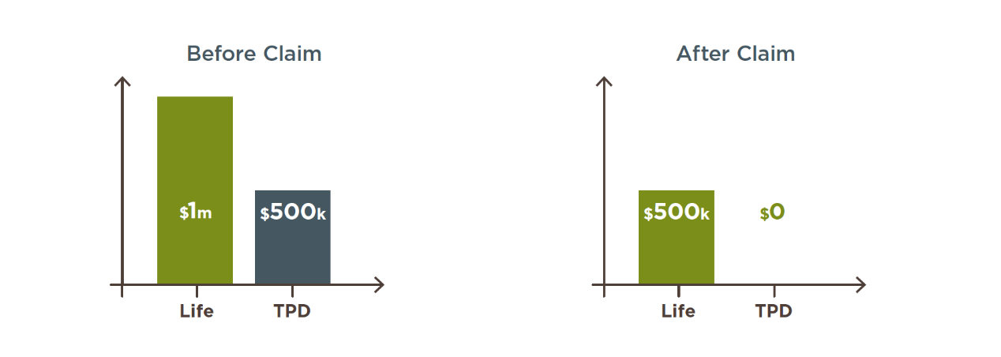
Did you know?
There’s a common exclusion on life cover policies that means you’re generally not covered for suicide for first 13 months of taking out cover or reinstating your policy. You can find details of any exclusions in your Product Disclosure Statement (PDS).

Want to know more?
If you’d like to discuss any of the content in this article and how it may apply to you, please call me on XXXXXXXXXX.

